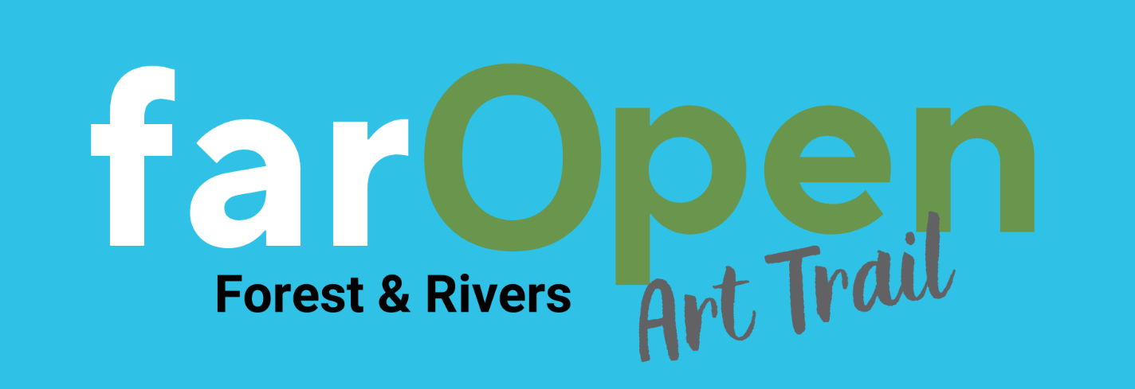

SEEKING ARTISTS FOR SHARING | Highview, Yorkley  This venue has been part of the art trail for several years.  A conservatory offering some wall hanging space and shelves and window sills for 3D work. A large garden with fabulous views for sculpture.  There is space for about 7 artists inside  Please contact Elaine Jackson, elainejackson10@hotmail.com
ARTISTS LOOKING FOR VENUES | Nina Oakman, stained glass panels, Glass enamels, textured abstract fused glass, is looking to share a venue near Ross.  Here is Nina’s email oakwoman1@gmail.com  Tony O’Hare – origami decorations, pictures, cards & gifts. Seeking to share a venue in or near Monmouth. My email is tonyohare123@gmail.com .

